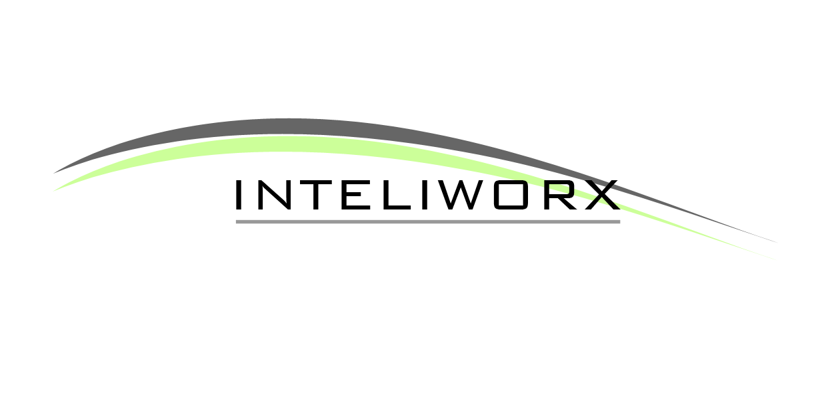

APPLICATION DEVELOPMENT | PROJECT MANAGEMENT | ICT PROCUREMENT | PROCESS AUTOMATION

COMPANY PROFILE

ABOUT US:
INTELIWORX Technologies Limited (INTELIWORX) was established to bring change to public sector services through the use of ICT, lead in private sector innovation and thus consequently raise the standards of ICT design and implementation in Nigeria. We hope to build a reputation synonymous to excellence and innovation and upon which take our services around the country and region. We demonstrate ability in database technology, web based and client/ server tools and network architectures to deliver desired ICT solutions. We strive to achieve by combining contemporary software technology, robust network Infrastructure and state-of-the-art hardware with the resourcefulness of a team of highly skilled professionals with a collective wealth of experience.
Where We Are Coming From? – History
The company was formed in 2009, by a team of young, versatile entrepreneurs who have acquired extensive expertise in various facets of IT services. With core competence in the area of ERP solutions, network Infrastructure design and layout and custom-designed software applications using proprietary and open-source development platforms, we are well positioned to render value-added services to every individual industry whether public, private or non-governmental, as well as improve public confidence in the Nigerian IT industry.
With business office located in Kaduna, INTELIWORX Technologies Limited has within the limited time of commencing business operation, been able to provide innovative and cutting edge IT services and other related activities to various classes of clients, cutting across both the public and private sectors. We have also brought new standards into the industry; by approaching each client’s project with a well thought-out solutions that has helped positioned them as an emerging leader in their respective industries.
Our goal has been to exceed the expectations our clients by offering them outstanding customer service, increased flexibility, and greater value for their investment, thus optimizing system functionality and improving operational efficiency.
Where We Are Today?
As at today, we are proud to say that we have established ourselves as a dependant partner, delivering services on time and meeting expected standards. As evident from our client base, this is a lot for an upcoming venture. However, our plan is to dominate the industry while concentrating our strength and activities on other well rewarding pursuits. As such our Vision is to become the market leader in the design, development and deployment of a complete suite of IT services by the year 2O15. In order to effectively bring this to fruition, we shall be guided by our Mission which is
“Delivering excellent and value-added ICT services through the combination of creativity, innovation and a well motivated staffs’ entrepreneurial drive “
Who We Are?
The company’s activities are directed by and based on our core values. These values have become a culture for all staffs of the company and have extended to service delivery and customers. Our values make us who we are today. We at INTELIWORX pledge to consistently;

- Promote PROFESSIONALISM ……. Among ourselves and with our customers
- Encourage RESOURCEFULNESS …… support creativity and reward outstanding performance
- Embrace INNOVATION ……. Drive it and take advantage of its opportunity
- We are DEPENDABLE ……. Positioned to creatively create value added services for client’s enhanced business efficiency
- Deliver EXCELLENT SERVICES ……. Set the pace for today’s competition

WHAT DO WE DO?
Though an integrated IT firm, we however focus on key areas where we have gained competence and can deliver exceptional value. This we achieve by tapping from our team’s entrepreneurial capabilities in order to provide the best of services that not only delight our clients, but also set industry standards. Specifically, our business focus is on the following among several others:
- Software Development
- Project Management
- ICT Procurement
- Process Automation and Re-engineering
- ICT Consulting and Training Services

OUR MANAGEMENT TEAM:

Abubakar Sadiq Isa is the Chief Executive Officer. He holds a Masters in Operations Research and has worked in the public and private sectors holding both technical and administrative positions. Actively involved in application development he has also served as a member of ICT and education committees at national level. These include:
- Secretary, Nigerian Information Technology Development Agency – NBTE Technical Committee on the Establishment of Virtual Libraries in the Higher Technical and Vocational Education and Training Sub-Sector. (June’05 – Feb ‘06)
- Member screening committee for the development and launch of the JAMB web portal.

While working in the technical education sub-sector he was responsible for recommending, reviewing, coordinating and managing ICT Projects for the National Board for Technical Education and its sub-sector.

Abdulsalam Lawal is the General Manager Technical Services and is responsible for software development and establishing protocols and standards for technical projects. He is a software architect with extensive experience in software development and deployment. He is comfortable developing applications using either open source or proprietary platforms. He graduated with distinguishing honor from Bayero University Kano with a degree in Business Administration before discovering a passion and flair for software development. He advanced to obtain certificates from several institutes including the New Jersey Institute of Information Technology. He has developed inventory management, human resources, payroll, transport and several other applications.
Abdulrauf Aliyu is the General Manager Business Development and is responsible for research and analysis, assessing organizational performance, customer relationship management and corporate marketing and publicity. He held similar positions working as Head of Business development and Head Marketing and Credit Risk Management in the banking sector. He holds a Masters degree in Public Financial Management and is currently undertaking another Masters degree in Development Studies. He has attended seminars and courses on strategic management, business development and marketing, organisational effectiveness and business process improvement with the Kaduna Business School, Strategic Management Centre, Central Bank of Nigeria, World Bank and the British Council.

Ibrahim Tanko is the Art Director for Inteliworx technologies; he is responsible for all company designs including logo identities. He is an expert in graphics design and animations. Ibrahim is a graduate of quantity surveying from Ahmadu Bello University Zaria and has contributed immensely to the company's branding and designs.

The General Manager Operations is responsible for managing the deployment of products and services and provides customer support. He oversees all day to day maintenance related activities and ensures proper use of resources and meeting service level agreements.

Other Key Staff:
Abdullahi Danasabe is an expert in network infrastructure and telecommunication, datacenter management, hardware configuration and maintenance. He graduated with a Masters Degree in Network Systems from the United Kingdom in 2010.
Mohammed Abdullahi is a Developer with Inteliworx Technologies. He is skilled in several programming and scripting languages and has contributed to several projects such as the Premium Pension Retirement Management System. He is also a certified IT/IS project manager.
Islam Wali is a Senior Developer with Inteliworx Technologies. He graduated cumlaude from Concorde University, West Virginia, U.S.A. with a B.Sc in Computer Information Systems. He is comfortable in computer design, animation, development and administration. He has worked as an I.T. consultant for organizations in Morocco, Argentina and Nigeria.
Fatima Fika is a Developer with Inteliworx Technologies. She graduated with a distinction in her Masters in Computing and Information Engineering from Robert Gordon University, Aberdeen, United Kingdom. She is a skilled software developer and has worked on several areas concerning data mining, advanced data structures and information security.
Dauda Musa Wulgo is an expert application developer based on agile methodologies and service oriented architecture. He has developed several commercial applications concerning human resources, payroll, biometric systems and mobile solutions.

Structure of our Technical Services Department
Our Project Management Process:
Project Supervision
Guidelines and Standards
Trainings & Skill Identification
Software Development
Software Maintenance
Development Teams Supervision

Capacity Building

Core Developers
General Manager Technical Services
Fringe Developers 1
Technical Support
Software Development
Fringe Developers 2

Customer Response & Feed back
Software Development
For all project we implement for clients we adapt the PRINCE2 project management approach as depicted in the diagram below.
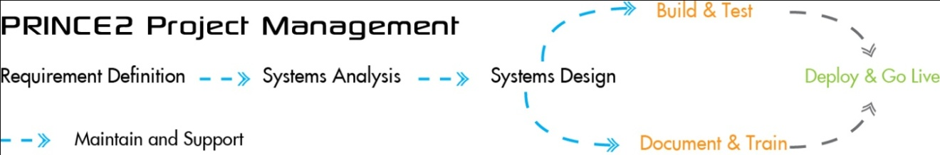

Our Business Model:
To guarantee the success of our client’s project, we have in place a well structured business model which also serves as a blueprint used to successful execute projects assigned to us. This blueprint incorporates our innovative concepts into a flexible and broad level view of how our client’s employees and partners will experience the IT solutions that we design, develop and deploy.
Similarly, given that we are product agnostic, we therefore provide only tailored IT solution suitable only for their peculiar needs, that is to say we make sure that our products and services aligns with our clients’ anticipated goals.
As such, our business model framework or blueprint takes the following process:
- Open Assessments – A comprehensive review of the existing business process or infrastructure to identify enhancement opportunities
- Strategic and Solution Planning – A short term project to develop a roadmap to a transformed organisation that aligns IT to business strategy.
- Business Case Development – A document to help quantify and justify the cost of project based on the anticipated project benefits including reduced overhead cost or increased efficiency
- System Integration – Services to implement desired project that can seamlessly integrated with existing applications (if needs be)
- Business Process Renewal and Change Management – Management of change process for the people and process portion of the project.
Our Solutions
- Erams
- RevMate
- Petroworx
- Foodbook
Erams
Background
During the April 2011 elections Inteliworx Technologies deployed an election reporting and monitoring system (ERAMS) in two States of the Federation; namely Jigawa and Kaduna States. During this trial period field reports were sent from a total of 303 polling units spread across these two States of the Federation. These reports were sent by SMS to a designated mobile phone number. This mobile phone number which was hosted on a web server transferred all verified incoming SMS from polling unit reps to a web portal which in turn presented the information in both tables and charts online. Several screenshots of such online reports can be found in the appendix.
The main type of reports conveyed by our ERAMS includes:
- Polling Results – electronic collation of data at the various levels of the electoral process through the use of GSM technology. If elections are conducted in an area of non-GSM coverage the data will be immediately transmitted once mobile GSM device moves into GSM coverage area. A java applet may also be designed and installed on mobile GSM devices of INEC officials for easier transmission of results.
- Situation Reports – communication of field status reports via GSM on activities such as arrival of materials, start and end of voter accreditation and start and end time of voting.
- Digital Map of Election Process – A real-time, graphical representation of ongoing elections. Information presented includes:
- Voting patterns and trends as elections are being conducted
- Tracking of materials distribution and movement
- Country searchable map for statistics, situation reports and results
All of the above parameters can lead to the derivation of credibility ratings for wards, local governments and states.
RevMate
We are offering Bauchi BIR RevMate which is an integrated modular tax administration solution with an open source database for easier, more flexible and cost-effective management. In as far as taxpayers do not meet their tax obligations the computer system monitors processes, initiates reminders, produces tax account statements, calculates penalties and prepares required documents for possible legal enforcement of taxes. Moreover, this system allows comparison, exchange and matching with data from BIR and other stakeholders. Also, Tax Mapping is on our roadmap. This is where tax payment data and transactions are represented graphically.
From the perspective of the user, the introduction of RevMate as a unified system for the administration of all taxes simplifies assessment and collection processes, avoids data duplication, and makes the service delivery more efficient.
From the perspective of the tax authority, RevMate ensures an increase in revenue collection by making taxation more transparent, leads to better tax compliance, easier tax collection, and more effective enforcement.

Clients:

- Bauchi State Board of Internal Revenue (BABIR)
- ICT Advisory and Infrastructure Design
- ICT Training & Capacity Building for the Board
- Website and Portal Development
- Integrated Tax Administration Software Deployment
  - Including a Revenue Collection, Monitoring and Reporting System
- Gombe State Board of Internal Revenue (GMBIR) - A Protax/Access Bank Plc. Sub-Contract
- ICT Advisory and Infrastructure Design
- Integrated Tax Administration Software Deployment
  - Including a Revenue Collection, Monitoring and Reporting System

- Independent National Electoral Commission (INEC)
- Supply of 120 customized workstations to locations around the North-West.
- Nigerian Defense Academy, Kaduna – A Darodaz Ltd. Sub-contract
- Web Portal for NDA On-line Application 2009/2010

- NBTE Institutional Management System, Kaduna – In Alliance with Viatech Ltd.
- Web Portal for data gathering and analysis of the technical education sector

- Tafawa Balewa Square Management Board, Lagos
- Web Portal for Lagos Trade Center

- Vivid Solutions Ltd.
- Project Management of Nigerian Defense Academy Cadet Information System, e-learning and e-library.
- Daddo Maritime Services Ltd, Apapa – Lagos
- Web Application to generate business intelligence on the maritime sector and automate maritime operations

PARTNERSHIPS:
- Technology Partners
- Cerebro Systems Ltd. – Desktop Applications.
- Darodaz – ICT hardware supply and deployment.
- GiTTS - ICT training
- DSI Ltd. - Hardware infrastructure design and deployment, web application development and hosting.
- Business Partners
- Banks
Skye Bank Plc
Fidelity Bank Plc

BUSINESS OFFICES:
No. 1b Dan Buran Road,
Off Yahaya Road,
Unguwan Rimi GRA,
Kaduna.

CONTACTS:
Managing Director General Manager Business Development.
08034516120 08035293547

